VERILOG CODE:

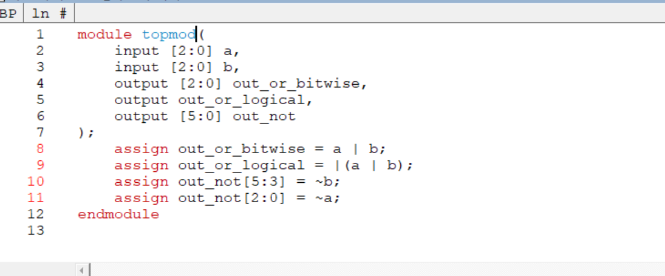

TEST BENCH CODE:

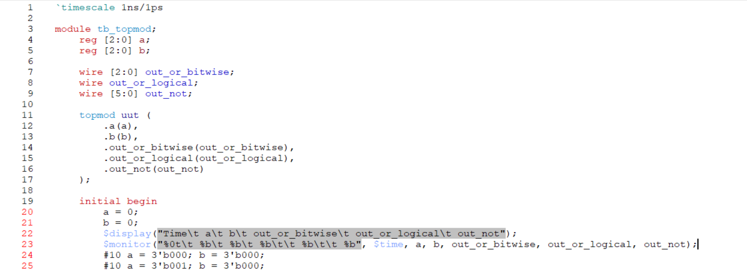

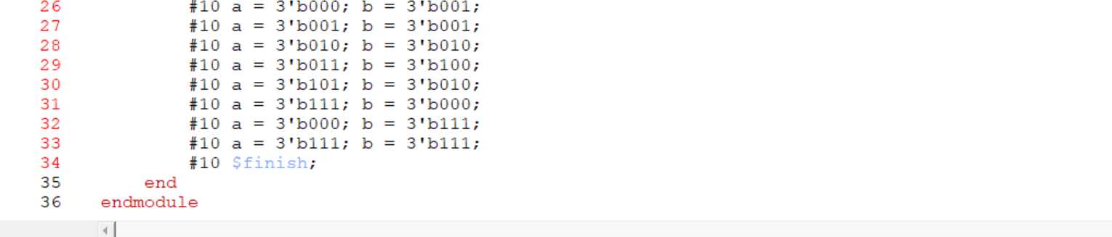

OUTPUTS:

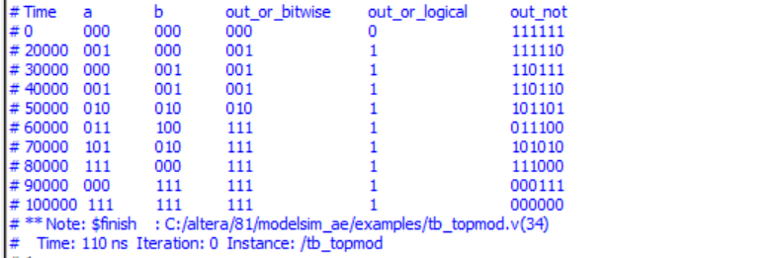



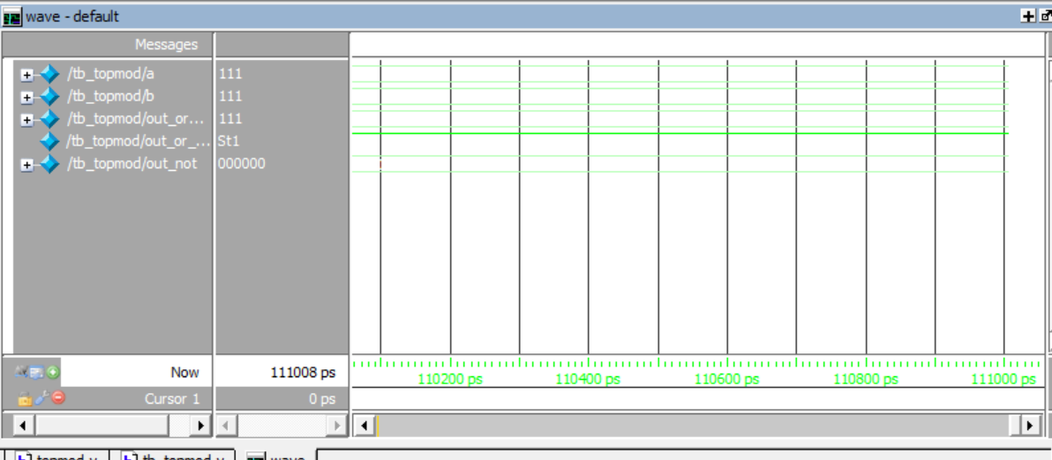

NAME:SAI TEJO VAISHNAVI MIDATHANA REG NO:126004230